Annexure-A
WORK SPECIFICATION OF INTERIOR DECORATION OF THE BOARD ROOM ON 2 ND FLOOR OF HEAD OFFICE
TAMLUK-GHATAL CENTRAL CO-OPERATIVE BANK LTD. TAMLUK,PURBA MEDINIPUR

SL. NO | WORK-TYPE | WORK- SPECIFICATION | ITEAM DETAILS & APPROVED BRANDS/ MANUFACTURERS | MODEL DESIGN
 |  |  | (A)PROVIDING & FIXING OF FALSE | 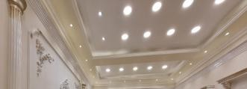
1. | FALSE CEILING | POP/GYPSUM | CEILING WITH EXPOSED G.I. GRIDE
 |  | BASED ROYAL | SUSPENSION SYSTEM (E-GRID U-
 |  | AESTHETIC | 1520 OR EQUIVALENT LOAD
 |  | LOOKS FALSE | CARRYING CAPASITY WITH3600
 |  | CEILING WITH | MM LONG,CROSS TEE
 |  | DESIGN | 1200MM/600MM LONG & WALL
 |  |  | ANGLE.THE WALL ANGLE SHALL
 |  |  | BE FIXED BY FASTENERS.
 |  |  | (B)ACCOUSTIC FALSE CEILING
 |  |  | MADE BY GYPSUM BOARD
 |  |  | (C) GROUP DESIGN ON SIDE DROP
 |  |  | BRAND- India Gypsum, Lafarge Gypsum
2. | ELECTRIFICATI | TOTAL | (A)ELECTRIFICATION WITH
 | ON | CONCEALED | CONCEAL WIRING BY 0.5 SQ
 |  | WIRING WITH | MM,0.75 SQ MM, 1.5 SQ MM, 2.5
 |  | LIGHTS & FANS | SQ.MM ,4.0 SQ MM WIRE
 |  |  | BRAND - FINOLEX / POLYCAB
 |  |  | (B) SWITCHES,BOARD,PLATE
 |  |  | BRAND- ANCHOR ROMA/HAVELLS CRABTREE
(C) MCB & DB BOX
BRAND- L& T /LEGARD
 |  |  | (D) 20 WATT 4K LED PANEL LIGHTS (20 PCS)
 |  |  | BRAND- PHILIPS/PANASONIC/CROMPTON
 |  |  | (E) WALLFAN (12”) –5 Pcs
 |  |  | BRAND -CROMPTON /HAVELLS
 |  |  | (F)8WATT - COB SPOT LIGHTS (20 PCS PCS
 |  |  | BRAND - PHILIPS/PANASONIC/CROMPTON
 |  |  | (G)PROFILE LIGHTS
 |  |  | (F) MODERN BRACKET LIGHTS (15PCS)
 |  |  | BRAND - PHILIPS/PANASONIC/CROMPTON
(G) CHANGE OVER SWITCH
BRAND- HPL / HAVELLS
3 | GLASS | DOOR, WINDOW | SAINT GOBIN /MODIFLOAT
 | Aluminum Sections | WINDOW PANEL etc. | LYCO

4 | PUTTY & COLOUR | CEILING | ASIAN PAINTS/ICI DULUX PUTTY & ROYAL OIL BASED PRIMER
4 | PUTTY & COLOUR | CEILING | ASIAN PAINTS ROYAL SHYNE/ICI DULUX VELVET TOUCH COLOUR
5 | PLYWOOD  ,LAMINATES & HARDWARE FITTINGS | FULLCEILING  LENGTH WALL PANELLING WITH BACK STRUCTURE BY 19 MM  PLYWOOD ON TWO SIDES OF  WALL | 19 MM THICK ISI CERTIFIED PLYWOOD | 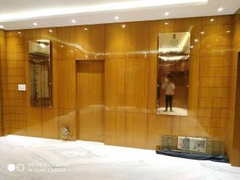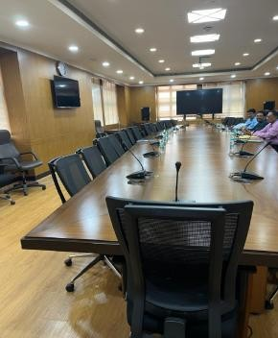
5 | PLYWOOD  ,LAMINATES & HARDWARE FITTINGS |  | 4.0 MM GREEN/CENTURY VENEER PASTING OVER PLYWOOD
5 | PLYWOOD  ,LAMINATES & HARDWARE FITTINGS |  | PREMIUM GRADE PU POLISH  BRAND-ASIAN PAINTS PU EMPORIO
5 | PLYWOOD  ,LAMINATES & HARDWARE FITTINGS | 12 MM PLYWOOD WALL PANELLING WITH 1.5 MM THICK STEEL  STRUCTURE | PREMIUM GRADE PU POLISH  BRAND-ASIAN PAINTS PU EMPORIO
5 | PLYWOOD  ,LAMINATES & HARDWARE FITTINGS |  | 1.5 MM THICK STEEL STRUCTURE
5 | PLYWOOD  ,LAMINATES & HARDWARE FITTINGS | 19 MM PLYWOOD  MAKE TABLE | HARDWARE FITTINGS WITH FITTING & FIXING  BRAND-GREEN PLY/CENTURY
5 | PLYWOOD  ,LAMINATES & HARDWARE FITTINGS | VENEER PASTING
5 | PLYWOOD  ,LAMINATES & HARDWARE FITTINGS | PU POLISH | BRAND-ASIAN PAINTS PU EMPORIO
6 | LOUVERS | LOUVERS DIGITAL PLANKS | LOUVERS DIGITAL PLANKS USED  BRAND-HUTCH | 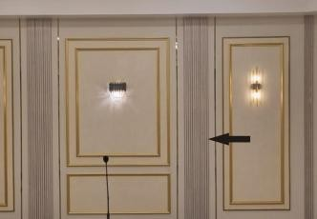
7 | T-PROFILE | T-PROFILE ON WALL | GOLD T-PROFILE ON WALL  BRAND-DELICA
9 | Door Lock / Door Handles | DOOR | BRAND- HETTICH
10 | DOOR CLOSURE |  | BRAND -Godrej / Archi
11 | PVC MOULDING BIT | PVC MOULDING BIT WITH NAIL FREE JOINING | PVC MOULDING BIT WITH NAIL FREE JOINING

12 | WOODEN FLOORING | WOODEN FLOORING | WOODEN 10.0 MM THICK PVC INTERLOCKING FLOORING .  BRAND-MIKASA /ARMSTRONG | 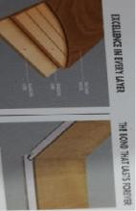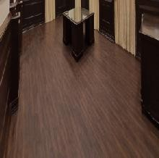
13 | ROMAN BLINDS |  | ROMAN BLINDS AS REQUIRED
14 | LAN CONNECTION | LAN CONNECTION ON TABLE | LAN CONNECTION ON TABLE  CAT 6  BRAND-DLINK
15 | SOUND SYSTEM | JBL SOUND SYSTEM WITH SPEAKERS | WATT CEILING SPEAKERS ( 6  PCS)
15 | SOUND SYSTEM | JBL SOUND SYSTEM WITH SPEAKERS | JBL GM -601 LM GOOSE NECK MICROPHONE (30 PCS)
15 | SOUND SYSTEM | JBL SOUND SYSTEM WITH SPEAKERS | JBL AMPLIFIER (1 PCS)

