ANNEXURE-A
INTERIOR DECORATION & FURNISHG WORK, ELECTRICAL,SOUND SYSTEM OF THE MEETING HALL ON 2ND FLOOR OF TAMLUK-GHATAL CENTRAL CO –OPERATIVE BANK LTD, TAMLUK, PURBA MEDINIPUR
(AREA-1890 SQ.FT)

SL. NO | WORK- TYPE | WORK- SPECIFICATION |  | ITEAM DETAILS & APPROVED BRANDS /MANUFACTURERS | SAMPLE PICTURE
1. | FALSE CEILING | POP/GYPSUM BASED ROYAL AESTHETIC LOOKS FALSE CEILING WITH DESIGN & ROYAL DOME |  | (A)PROVIDING & FIXING OF FALSE CEILING WITH EXPOSED  G.I. GRIDE SUSPENSION SYSTEM (E-GRID U-1520 OR EQUIVALENT LOAD CARRYING CAPASITY WITH3600 MM LONG,CROSS TEE 1200MM/600MM LONG & WALL ANGLE.THE WALL ANGLE SHALL  BE FIXED BY FASTENERS. | 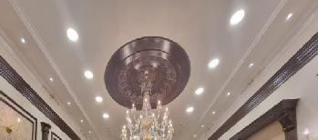  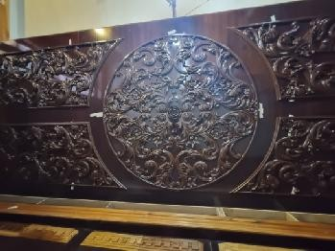
(B)ACCOUSTIC FALSE CEILING MADE BY 30”* 36” POP
BOARD/GYPSUM
(C) MOUILDING BIT (4” THICK )
ON THE FACE OF SIDE TRAY
 |  |  |  | (D) AESTHETIC LOOKS DOME (4’ RADIUS)
BRAND-
India Gypsum, Lafarge Gypsum

2. | ELECTRIFIC ATION | TOTAL CONCEALED WIRING WITH LIGHTS & FAN |  | (A)ELECTRIFICATIONWITH CONCEAL WIRING BY 0.5 SQ MM,0.75 SQ MM, 1.5 SQ MM,  2.5 SQ.MM ,4.0 SQ MM FINOLEX  WIRE  BRAND - FINOLEX / POLYCAB | Bracket Light  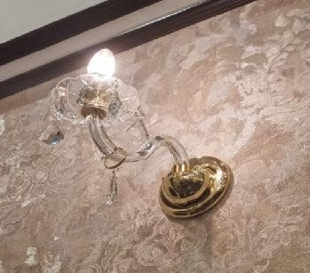
 |  |  |  | (B) SWITCHES,BOARD,PLATE
 |  |  |  | BRAND-ANCHORROMA/ HAVELLS /CRABTREE
 |  |  |  | (C) 20 WATT 4K LED PANEL LIGHTS (70 PCS)
 |  |  |  | BRAND- PHILIPS/PANASONIC/CROMPTON
 |  |  |  | (D)8WATT - COB SPOT LIGHTS (50 PCS )
 |  |  |  | BRAND - PHILIPS/PANASONIC/CROMPTON
 |  |  |  | ROPE LIGHTS WITH ADAPTER
(E) VINTAGE BRACKET LIGHTS (15
PCS) BRAND - PHILIPS/PANASONIC/CROMPTON
(F) MCB & DB BOX
BRAND- L& T /LEGARD

(G) WALL FAN (12”) –25 Pcs
BRAND-CROMPTON/HAVELLS
3 | PUTTY & COLOUR | WALL & CEILING |  | ASIAN PAINTS /ICI DULUX PUTTY & ROYAL OIL BASED PRIMER
 |  |  |  | ASIAN PAINTS ROYAL SHYNE/ICI DULUX VELVET TOUCH COLOUR
4 | POP BIT/PILLAR  /HEAD | ORNAMENTATION |  | POP MAKE MOULDING BIT (71  MM THICK) WITH FITTING & FIXING ON WALL | 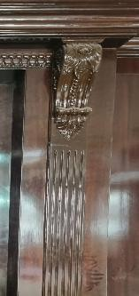
POP WALL PILLAR (ROUND) DIMENSION- H2438 MMX202MM WITH FITTING &
FIXING
DECORATIVE HEAD OVER PILLAR (SIZE-H308MMX W495MMX210MM) WITH
FITTING & FIXING
 |  |  |  | POP STRAIGHT PILLAR (SIZE- H2362 MMX W240MM)
5 | PLYWOOD & VENEER | WALL PANELLING WITH BACK STRUCTURE & ROYAL DESIGN WITH VENEER  PASTING |  | 19 MM THICK | 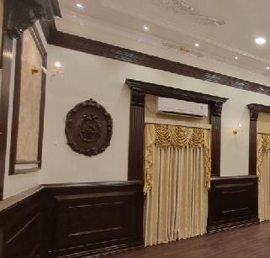
4.0 MM MAKE VENEER
BRAND - GREENPLY
/CENTURY PLYWOOD
 |  | MAIN PILLAR FULL HEIGHT PANELLING WITH ROYAL WORK & VENEER PASTING
 |  |  |  | 12 MM TOUGHEN GLASS DOORS
 |  | DIAS &PODIUM
 |  | ENTRY GATE &  GLASS DOORS |  | BRAND-SAINT GOBIN /MODIFLOAT
6 | WOODEN WORK | WOOD MAKE SKIRTING & BIT |  | SAGOON WOOD MAKE  SKIRTING MOULDING BIT (6’’) | 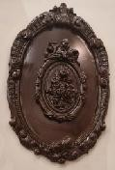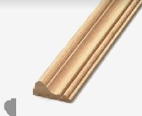
SAGOON WOOD MAKE MOULDING BIT (4”) OVER
PLYWOOD PANELLING
 |  |  |  | SAGOON 1” BIT ON VENEER
 |  |  |  | BATALI DESIGN WORK
7 | PU & DUCO POLISH | PREMIUM QUALITY PU MATT FINISH |  | PU SEMI-MATT FINISH PREMIUM QUALITY POLISH ON VENEER & DUCO POLISH ON PARIS BIT  BRAND - ASIAN PAINTS PU EMPORIO  ASIAN PAINTS DUCO POLISH WITH GLITTERING EFFECT. | 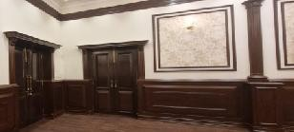
8 | WOODEN PVC FLOORING | WOODEN FLOORING |  | WOODEN 10 MM THICK PVC INTERLOCKING FLOORING  BRAND-MIKASA /ARMSTRONG | 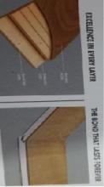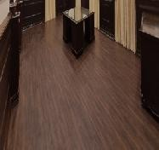
9 | CURTAIN |  | ROYAL LOOKS DOUBLE HEAVY PREMIUM CURTAIN |  | 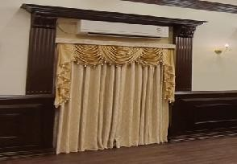
10 | LAN CONNECTI  ON | LAN CONNECTION ON TABLE | LAN CONNECTION ON TABLE  CAT 6  BRAND -DLINK
11 | PELMET |  | PLYWOOD & VENEER PASTING PELMET WITH WOODEN BATALI  WORK DESIGN & POLISH
12 | SOUND SYSTEM | JBL SOUND SYSTEM WITH SPEAKERS | 30 WATT CEILING SPEAKERS (12  PCS)
 |  |  | FRONT BOX 12 ‘’ (2 PCS)
AKG MINI 2 DUAL WIRELESS
MICROPHONE (2PAIR)
JBL GM -601 LM GOOSE NECK
MICROPHONE (5 PCS)
 |  |  | JBL AMPLIFIER (2 PCS)
13 | WALLPAPE R | PREMIUM BELGIUM WALLPAPER | ROYAL LOOKS PREMIUM QUALITY BELGIUM MADE WALLPAPER AS REQUIRED |  | 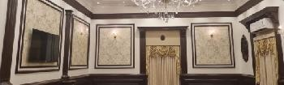
14 | WINDOW CHANEL | COATED ALUMINIUM SLIDING WINDOWS WITH ONE VISION  5MM GLASS | COATED ALUMINIUM SLIDING WINDOWS (12 PCS) WITH GLASS (ONE VISION)  BRAND- LYCO

